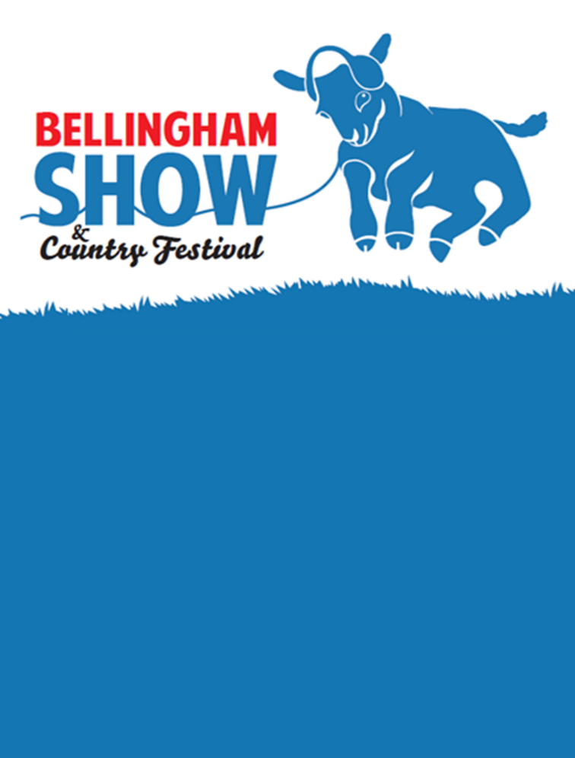

Saturday 30th August 2025

**Vintage Vehicle Section Entry Form**

|  |  |
| --- | --- |
| **Name** |  |
| **Address** |  |
| **Email** |  |
| **Phone** |  |

Personal Information

Vehicle Details

|  |  |
| --- | --- |
| **Make** |  |
| **Model** |  |
| **Year** |  |
| **Please Circle**  **Tractor Car Motorcycle** | |

Tickets/Passes will be sent to you no earlier than 2 weeks before the show

**I certify that all answers given here are true and complete to the best of my knowledge. I confirm I am the legal owner, or have permission to exhibit this vehicle and is fully insured.**

Signature ________________________________ Date _______________________

**Please return this form to, The Secretary, Bellingham Show, 59 Brierley Gardens, Otterburn, NE19 1HB or email** [**bellinghamshow@gmail.com**](mailto:bellinghamshow@gmail.com)